Installation Instruction

Contents

Requirements 1

Project details 1

Source code 1

PollExam project 1

PollExam.UnitTests 1

PollExam.Web 1

Database Engine 1

Demo website 1

Frontend 1

Backend 2

Screen shots 2

# Requirements

|  |  |
| --- | --- |
| Microsoft .NET Framework 4.5 | [Download](http://www.microsoft.com/en-us/download/details.aspx?id=30653) |
| SQL Server Compact Edition | [Download](http://www.microsoft.com/en-us/download/details.aspx?id=17876) |
| IIS 6+ | [Install instruction](http://www.iis.net/learn/install/installing-iis-7/installing-iis-on-windows-vista-and-windows-7) |
| Visual Studio 2012 (Express edition / Professional edition) |  |

# Project details

## Source code

**GitHub:** <https://github.com/linq2js/PollExam.git>

### PollExam project

Contains interfaces / classes for data access layer, data entities and services

### PollExam.UnitTests

Contains several unit tests for project services

### PollExam.Web

It’s main UI, include frontend / backend scope

Some layout files / customized scripts:

* Scripts/main.js
* Views/Frontend/Index.cshtml
* Views/Backend/Index.cshtml

### Database Engine

**SQL Server Compact Edition**

**Location:** PollExam.Web/App_Data/Database.sdf

In order to open / edit database entries, please use Visual Studio.

## Demo website

### Frontend

|  |  |
| --- | --- |
| URL | <http://poll.linq2js.com/> |
| Theme | Metronic 2.0.2 |
| Website category | Simple webshop |
| Plugins | Bootstrap, jQuery, FancyBox, BxSlider, jQuery Flot, jQuery Uniform |

### Backend

|  |  |
| --- | --- |
| URL | <http://poll.linq2js.com/backend> |
| Theme | Metronic 2.0.2 |
| Website category | CMS |
| Plugins | Bootstrap, jQuery, FancyBox, BxSlider, jQuery Flot, jQuery Uniform |

## Screen shots

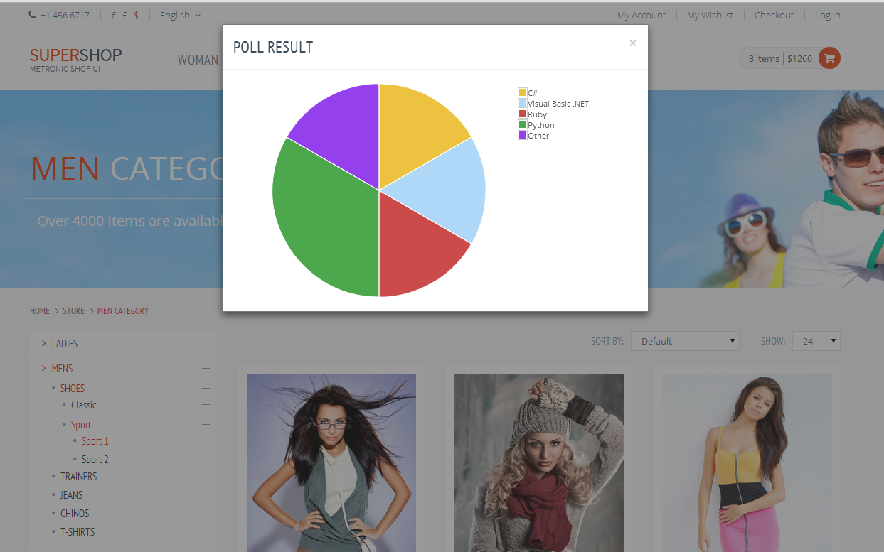

Frontend

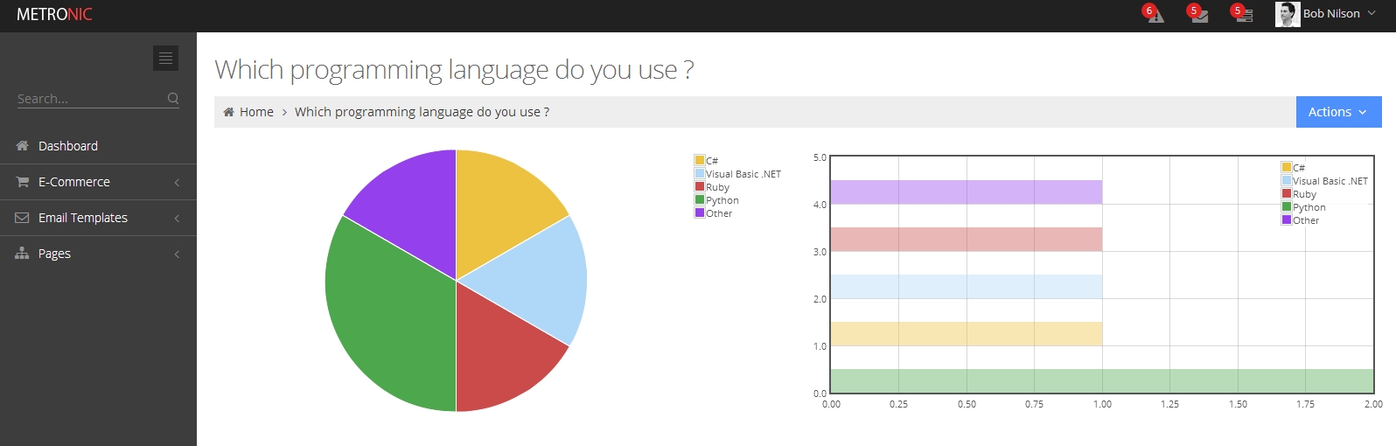

Backend

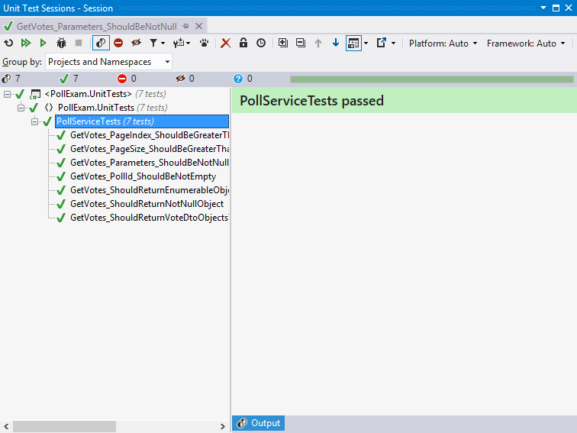

Sample unit tests